***Pre requisites***

***IBM CLOUD SERVICE ☁️***

|  |  |
| --- | --- |
| Date | 27 October 2022 |
| Team ID | PNT2022TMID45285 |
| Project Name | IOT Based Safety Gadget For Child Safety Monitoring And Notification |
| Maximum Marks | 4 Marks |

***Ibm Cloud Service:***

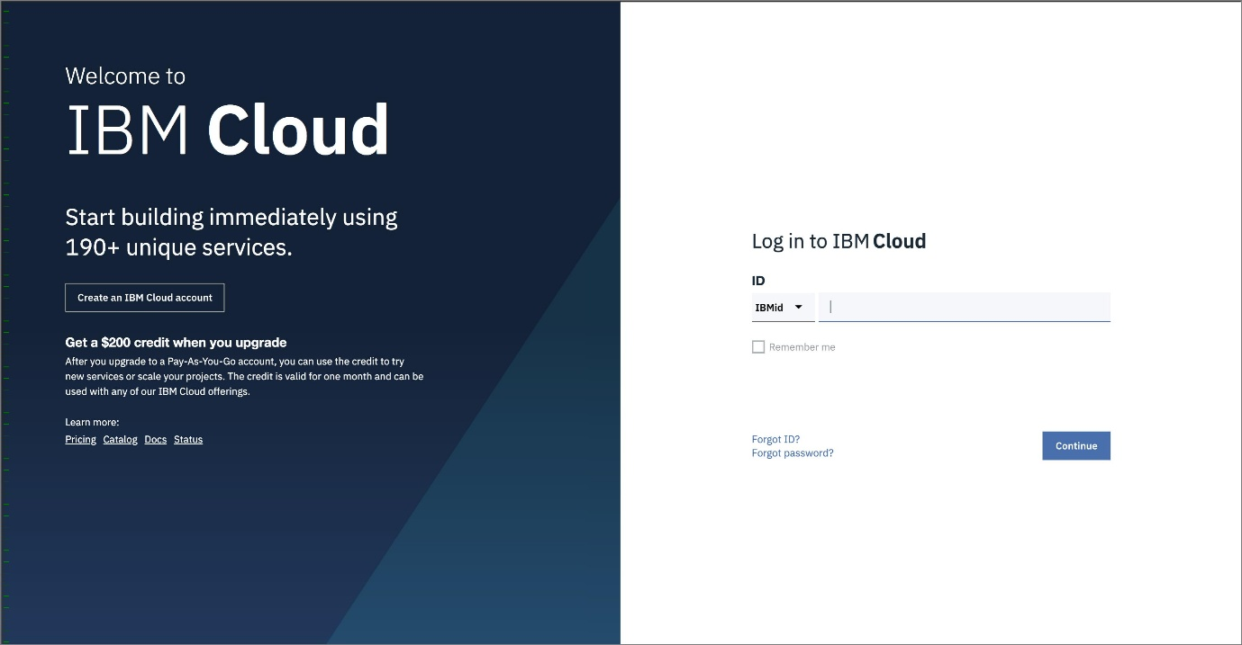

***1.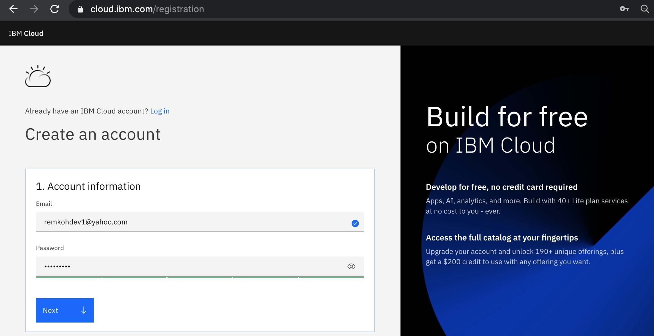In the Create an account window, enter your company email id and the password you would like to use. Click the Next button.***

2.***The Verify email section will inform you that a verification code was sent to your email.***

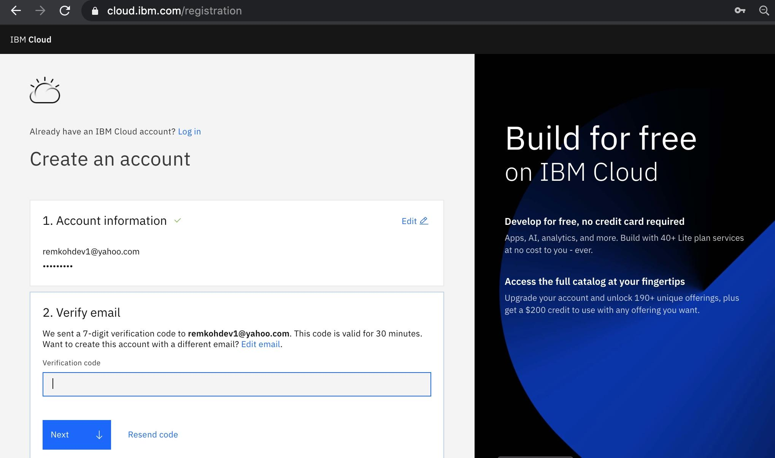

3.***Switch to your email provider to retrieve the verification code. Then enter the verification code in the Verify email section, and click the Next button.***

***4.Enter your first name, last name and country in the Personal information section and click the Next button.***

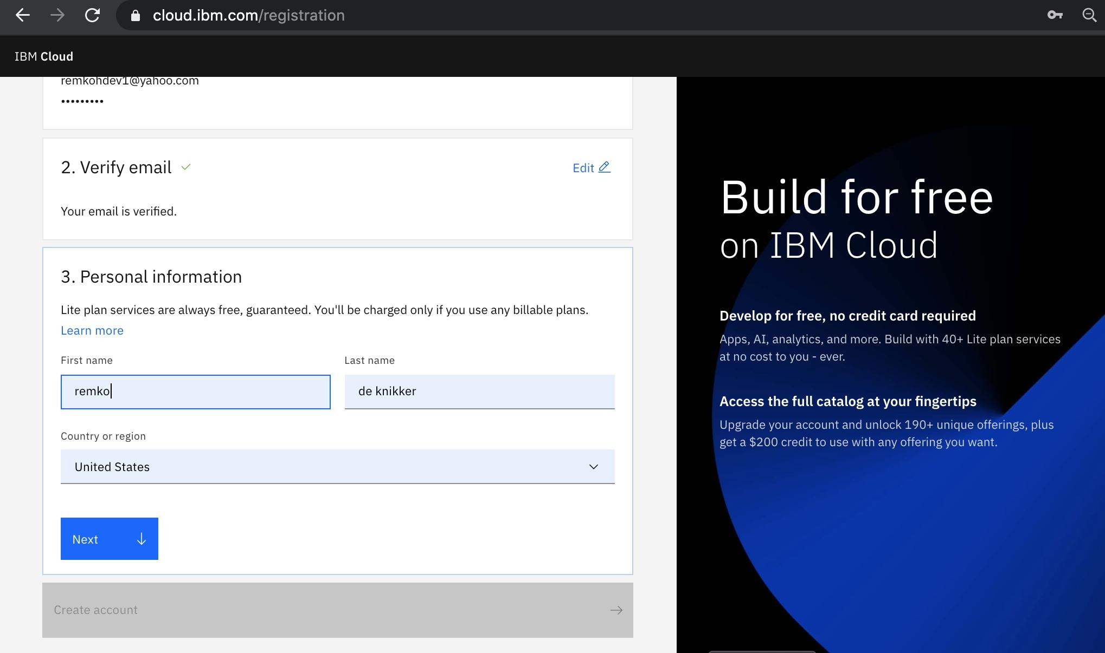

***5.Click the Create account button***

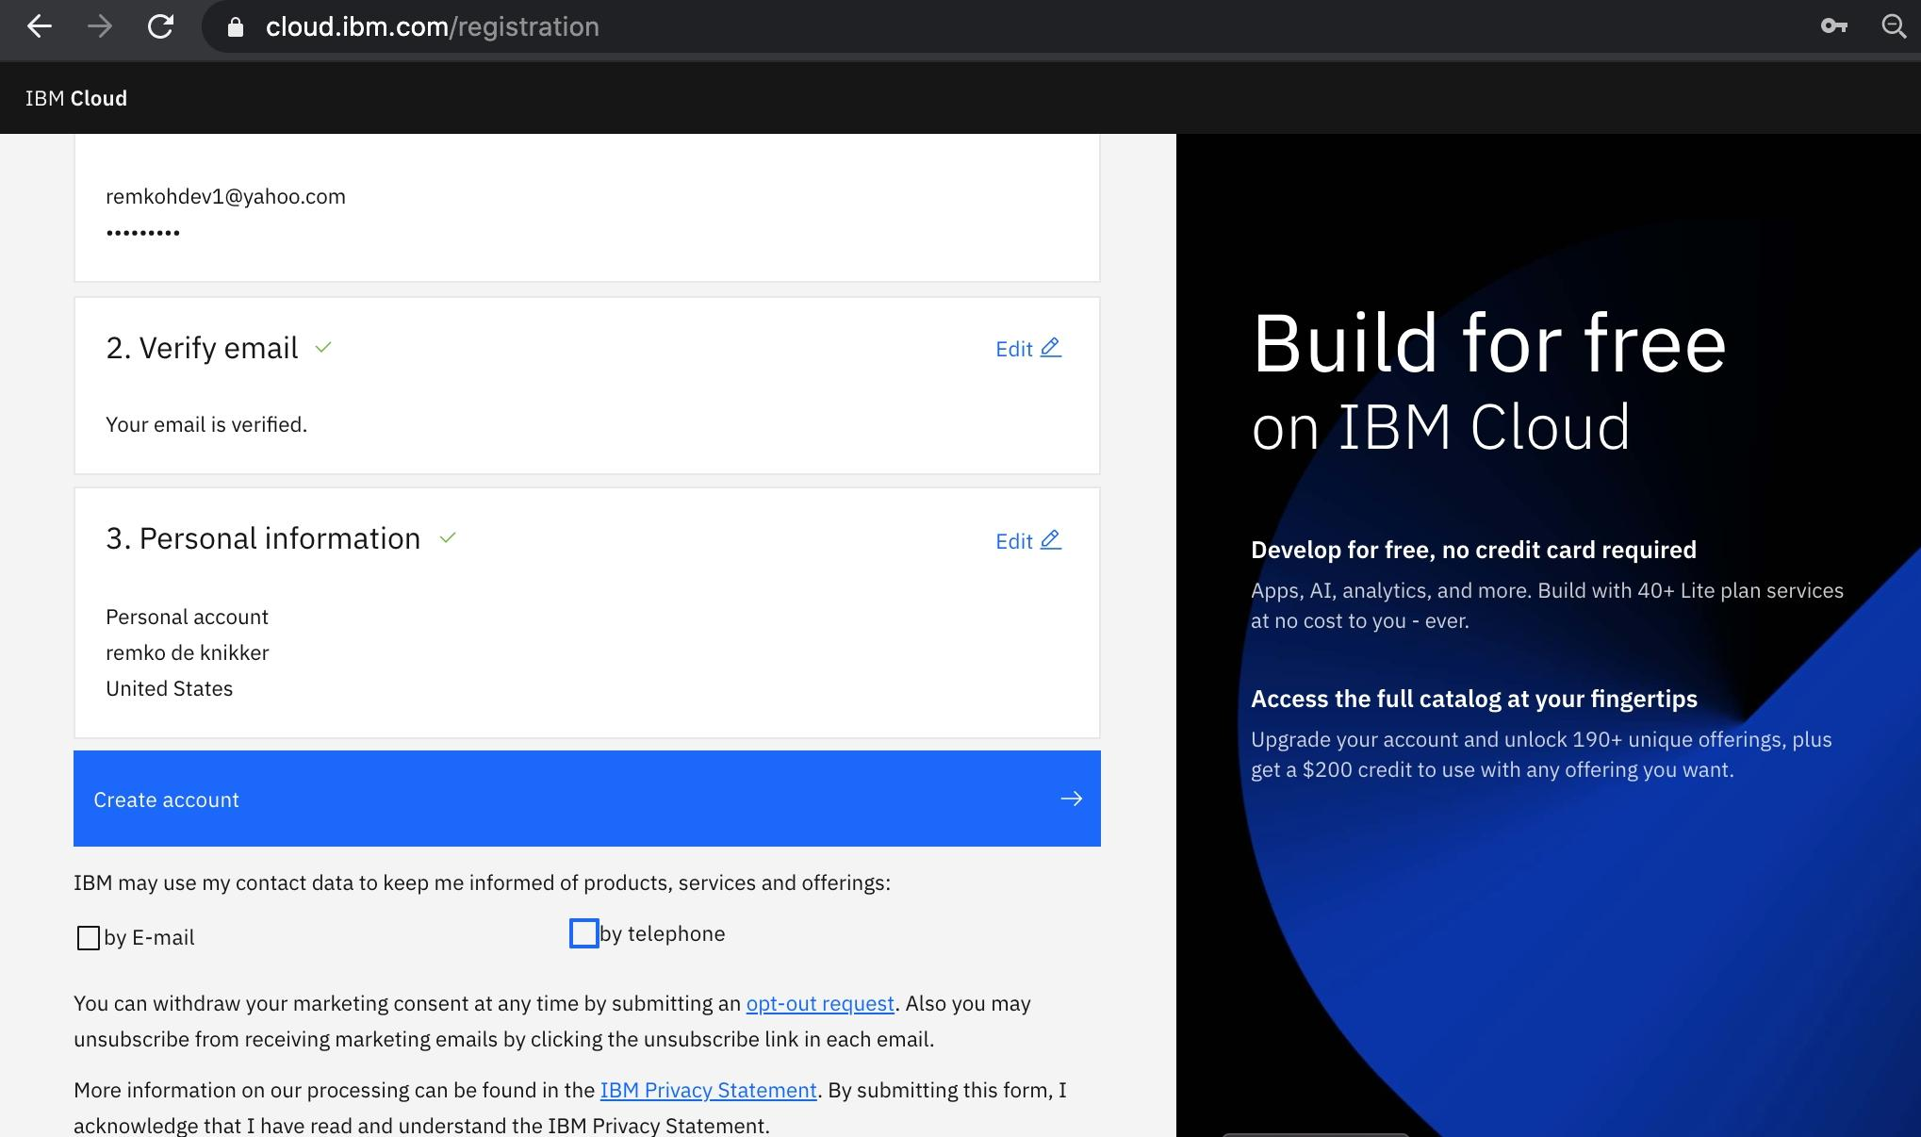

***6.After your account is created, review the IBM Privacy Statement. Then scroll down and click the Proceed button to acknowledge the privacy statement.***

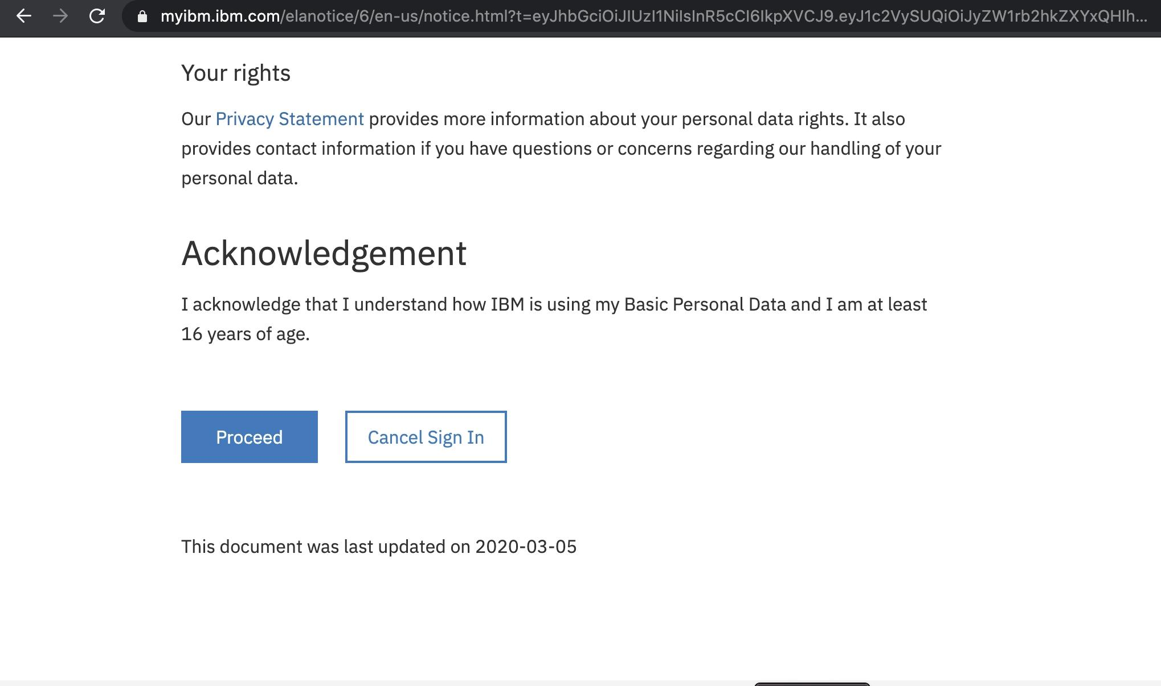

***7.You are now ready to login to the IBM Cloud. Open a web browser to the IBM Cloud console. If prompted, enter your IBM Id (the email ID you used to create the account above) followed by your password to login.***

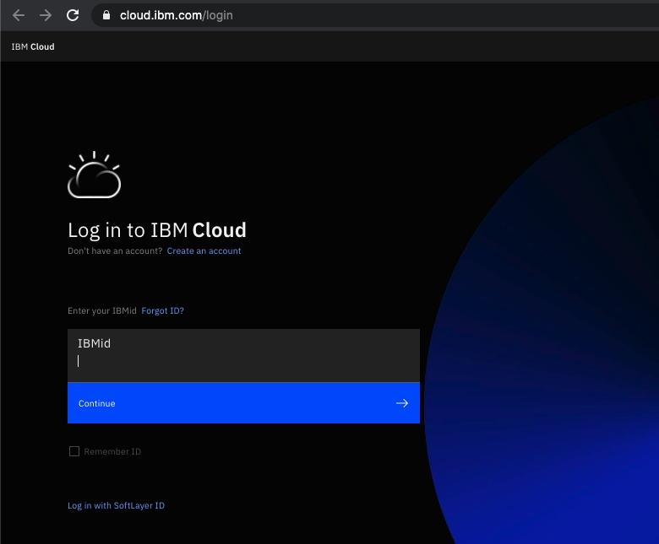

***8.The IBM Cloud dashboard page should load.***

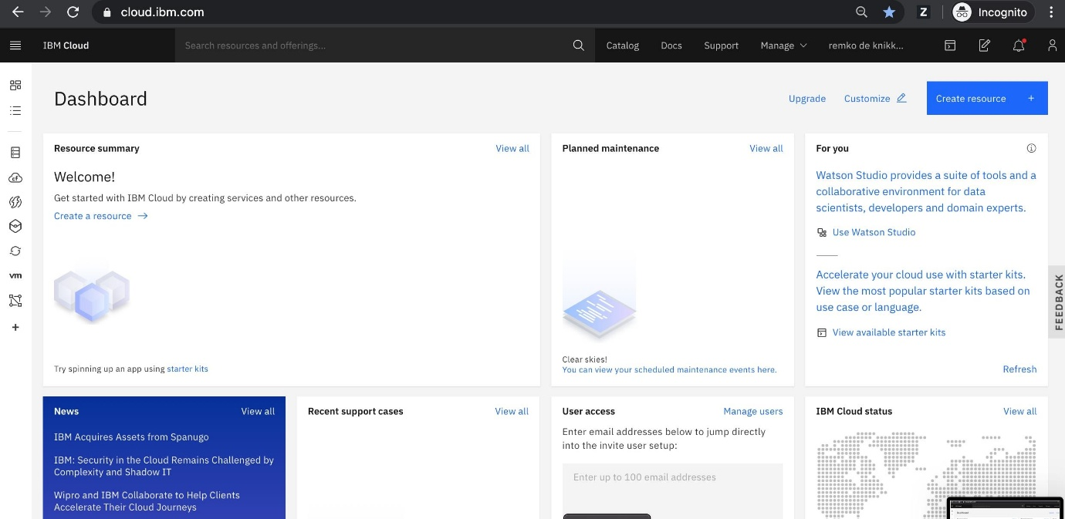

***9.You have successfully registered a new IBM Cloud account..***